Q1. Perform the following:-

1. Design a user friendly form for Employees Table.
2. Validate contents as appropriate from the Employees Table.

**BUTTON CODES:**

**First :**

BEGIN

GO_BLOCK('EMP');

FIRST_RECORD;

END;

**Next :**

BEGIN

GO_BLOCK('EMP');

NEXT_RECORD;

END;

**Previous :**

BEGIN

GO_BLOCK('EMP');

PREVIOUS_RECORD;

END;

**Last :**

BEGIN

GO_BLOCK('EMP');

LAST_RECORD;

END;

**Start:-**

BEGIN

GO_BLOCK('EMP');

EXECUTE_QUERY;

END;

**Show_record :**

BEGIN

GO_BLOCK('EMP');

EXECUTE_QUERY;

END;

**iNSERT**

BEGIN

GO_BLOCK('EMP');

DO_KEY(‘CREATE_QUERY’);

END;

**DELETE :**

BEGIN

GO_BLOCK('EMP');

DELETE_RECORD;

END;

**SAVE:**

BEGIN

GO_BLOCK(‘EMP’);

COMMIT;

END;

**EXIT:**

BEGIN

GO_BLOCK(‘EMP’);

EXIT_FORM;

END;

**Object navigator:**

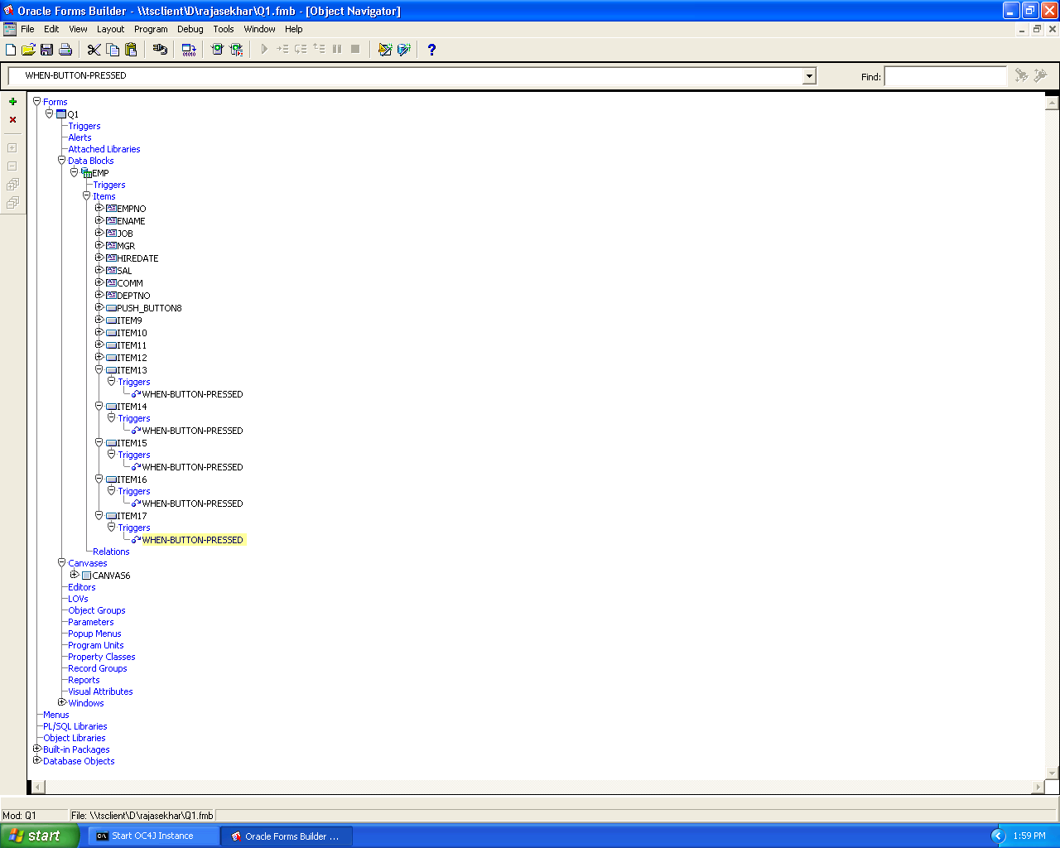

***Canvas :***

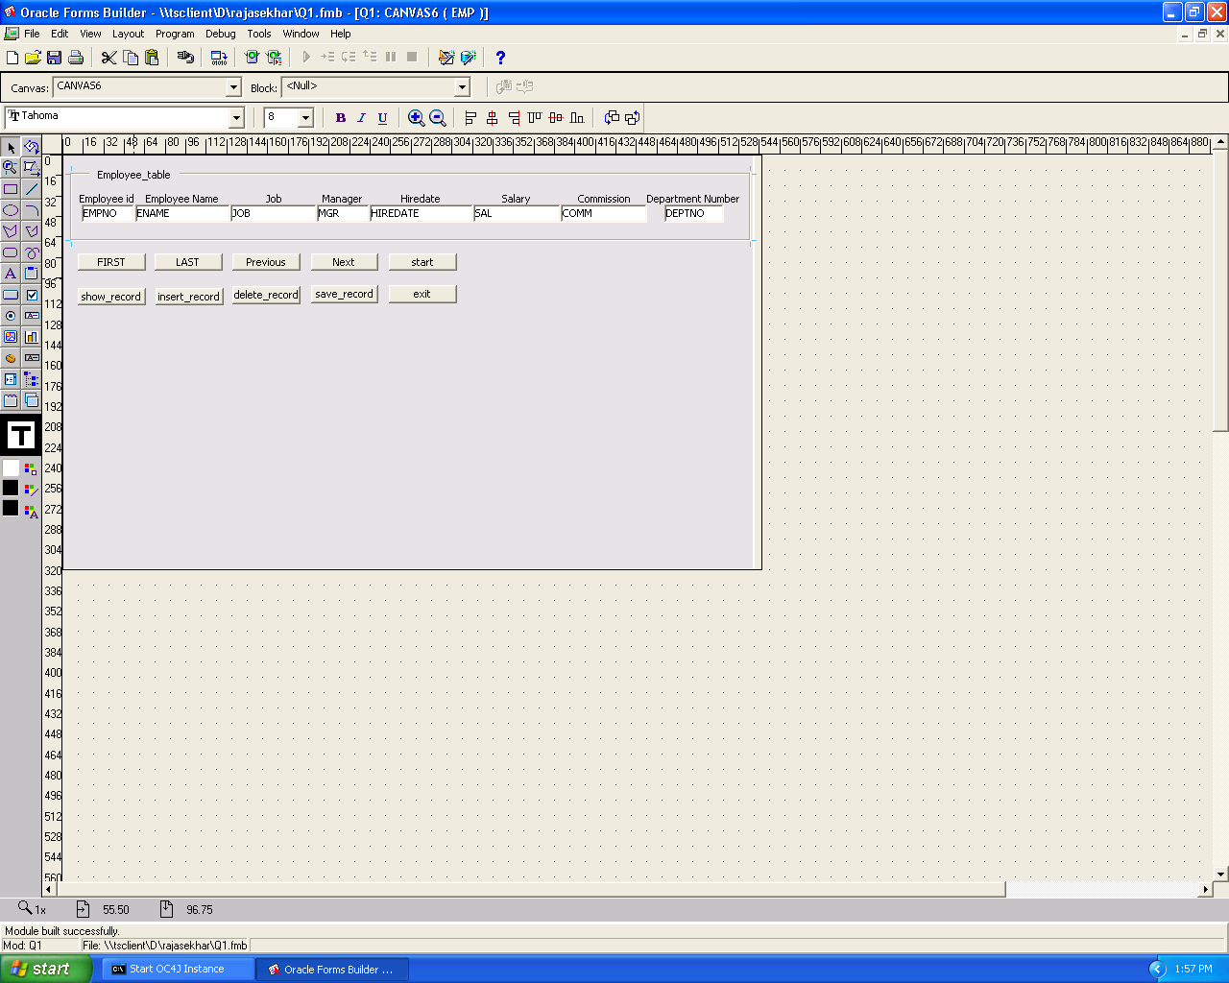

***Output for Forms :***

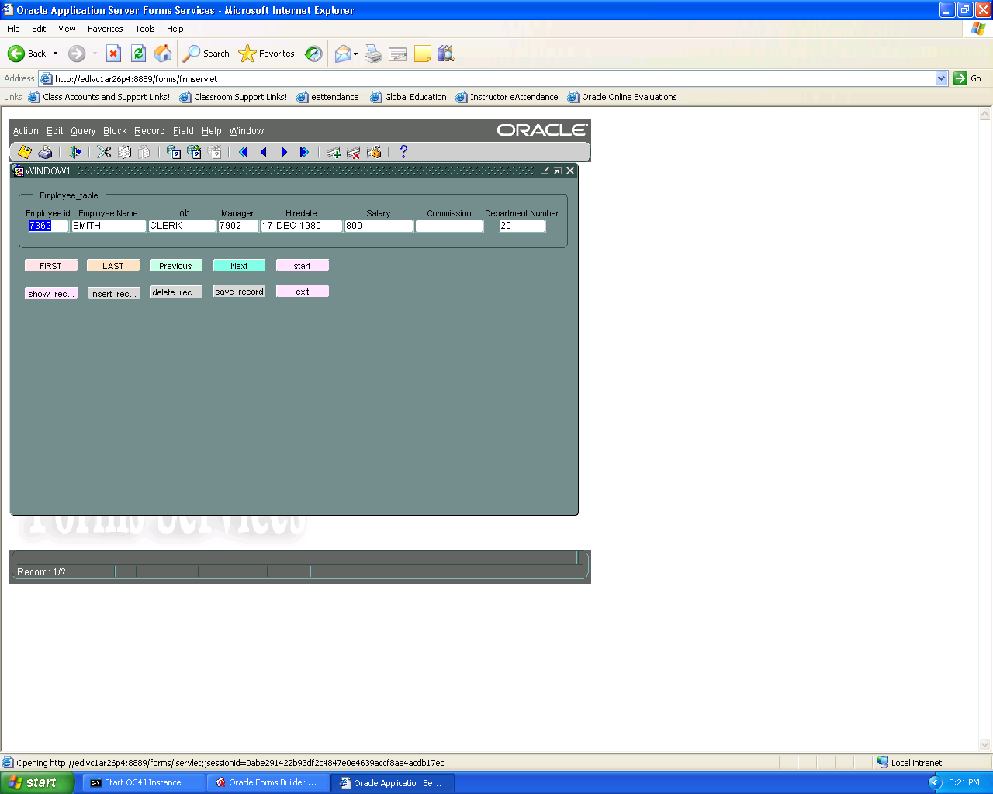

**Q3. Design the following reports:-**

1. Create a parameterized report that displays Master and Detail Information bound to a particular Department . The Department ID should be passed as parameter.
2. Display dept – wise subtotal and grand total of salary for employees.

***Object Navigator***

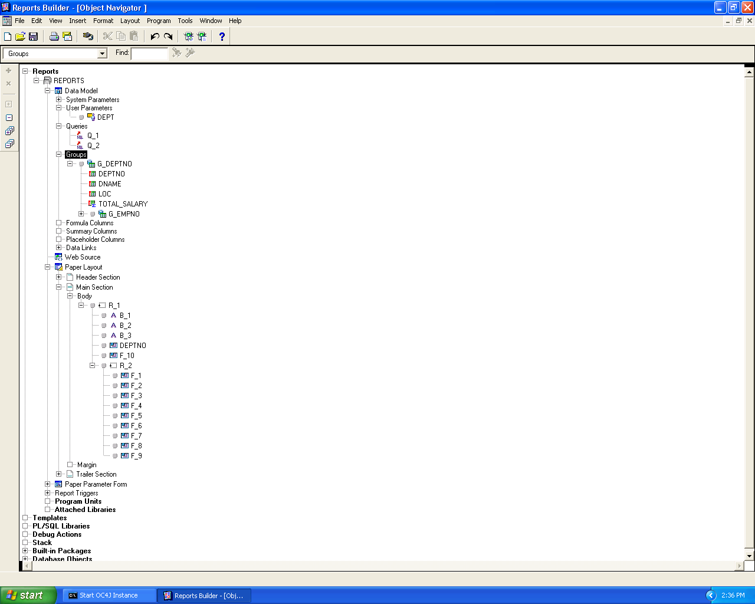

***Data Model***

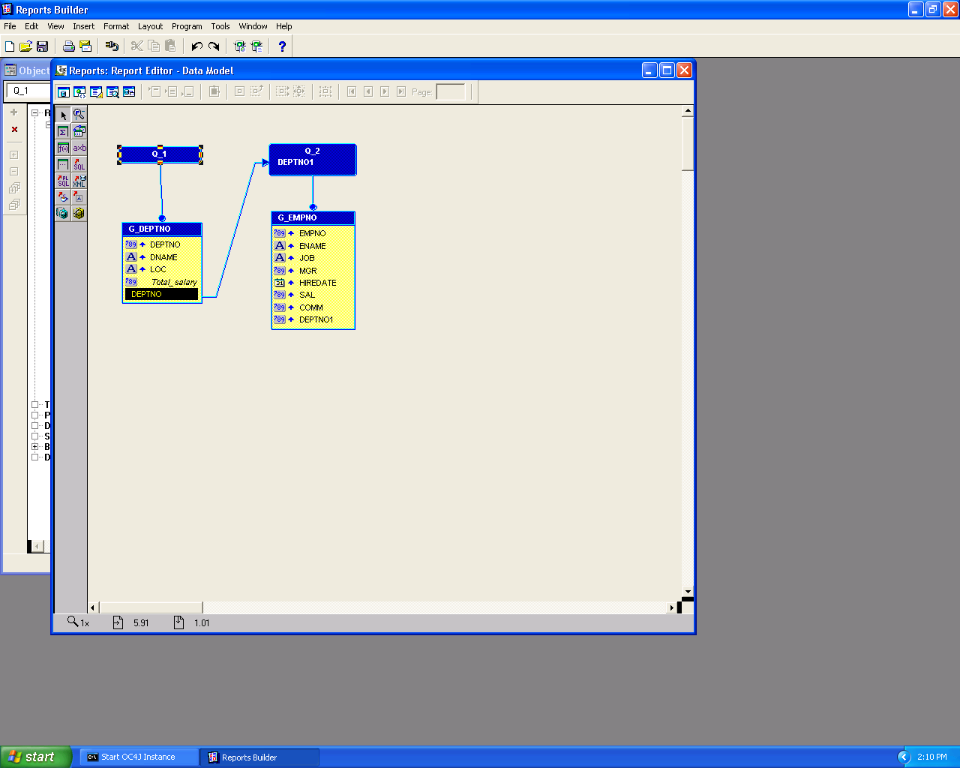

***Paper Layout***

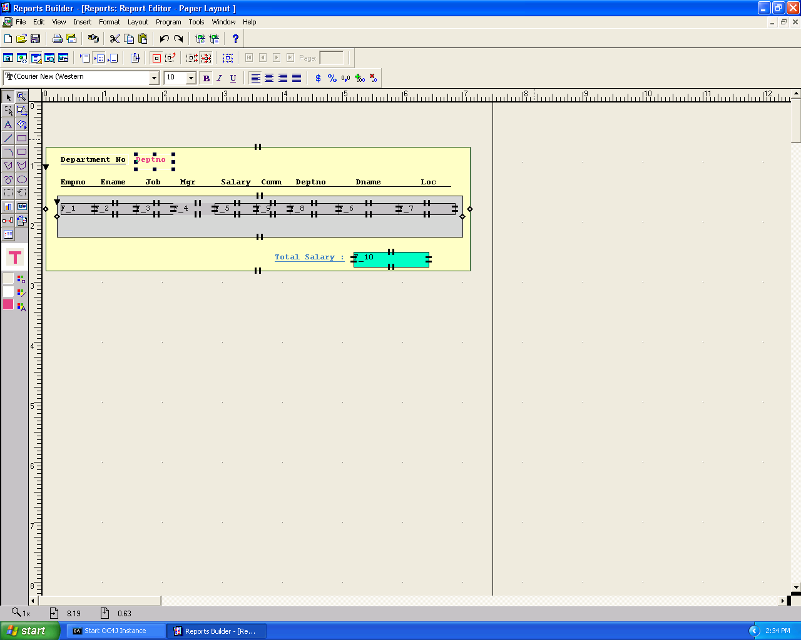

***Parameter Input***

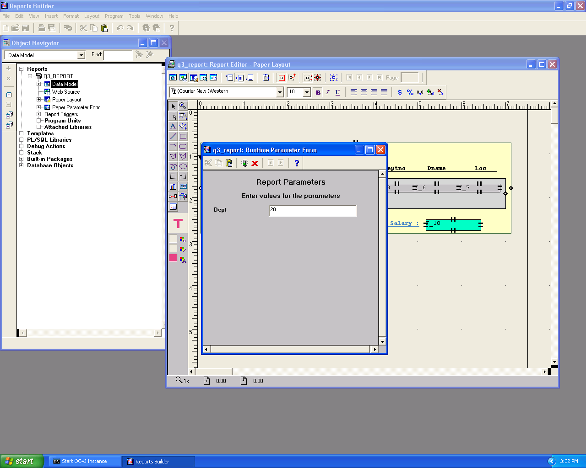

***Output***

